#include <stdio.h>

#include <stdlib.h>

main() {

// The first value of Lvalue will set the lowest number

int input = 0, count = 0, sum = 0, Nvalues = 0, Lvalue = 10000000, Hvalue = -1;

double average = 0;

printf("Enter an integer.\n");

scanf_s("%i", &input);

while (input != 0) {

if (input != 0)

{

// sum adds the total of numbers accumulated

sum = sum + input;

// count++ is same as count = count + 1

count++;

// if input is higher than Hvalue, Hvalue gets input

if (input > Hvalue) {

Hvalue = input;

}

// if input is lower than Lvalue, Lvalue gets input

if (input < Lvalue) {

Lvalue = input;

}

}

printf("Your total sum of count is: %i\n", sum);

// overcast the output in this division problem

average = (double)sum / count;

printf("Your highest number is: %i\n", Hvalue);

printf("Your lowest number is: %i\n", Lvalue);

printf("Your average of count is: %.2lf\n", average);

// continue loop until "0" is entered

scanf_s("%i", &input);

}

}

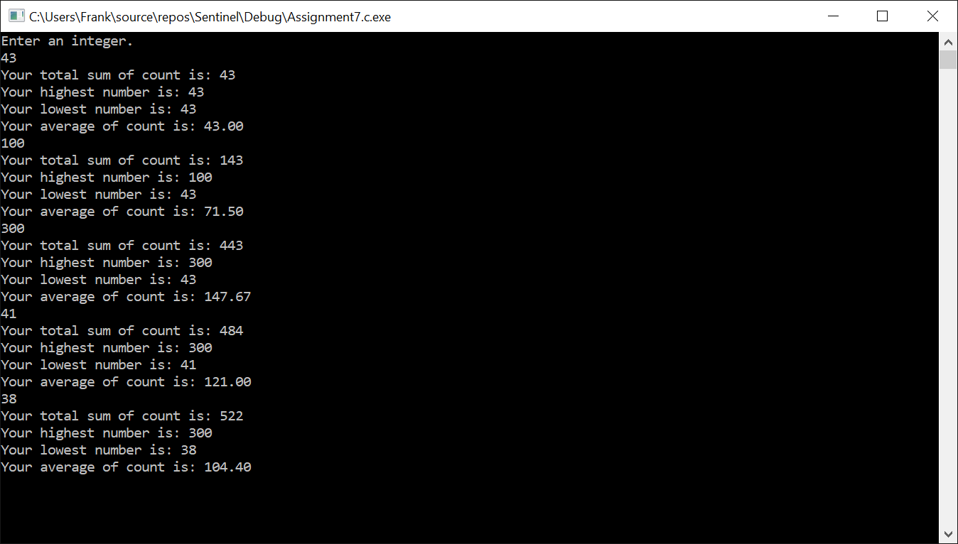

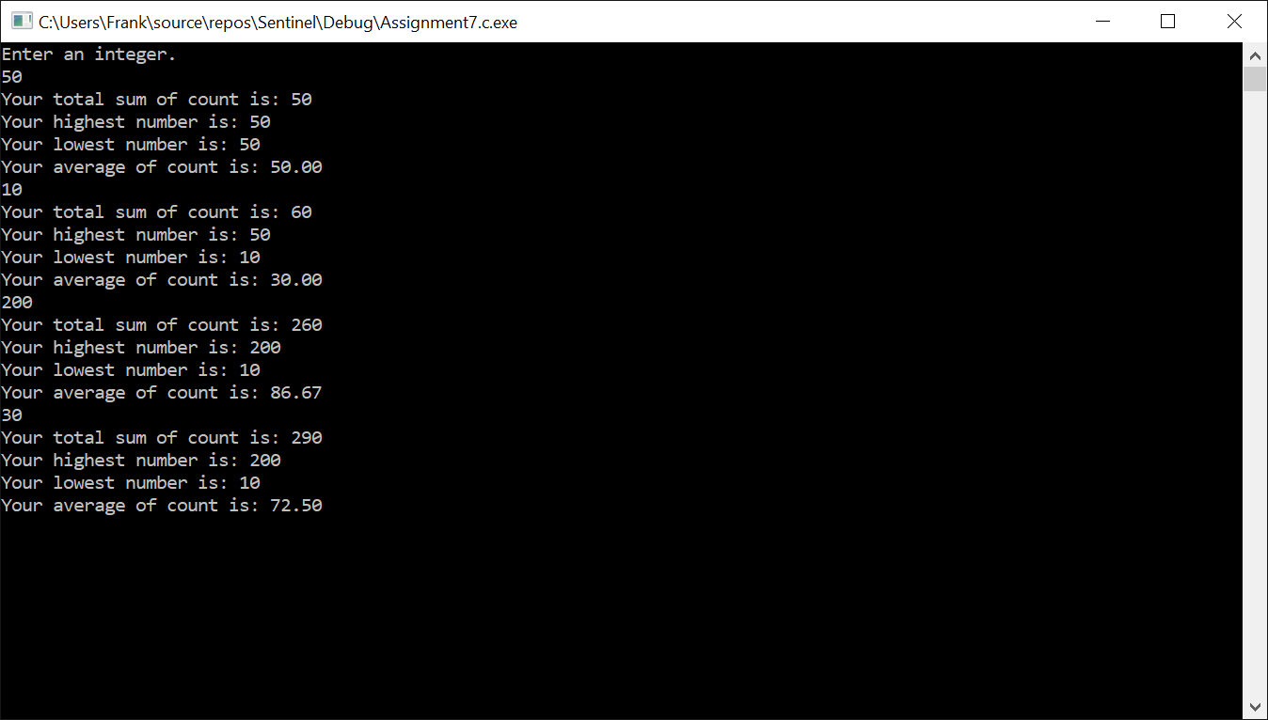

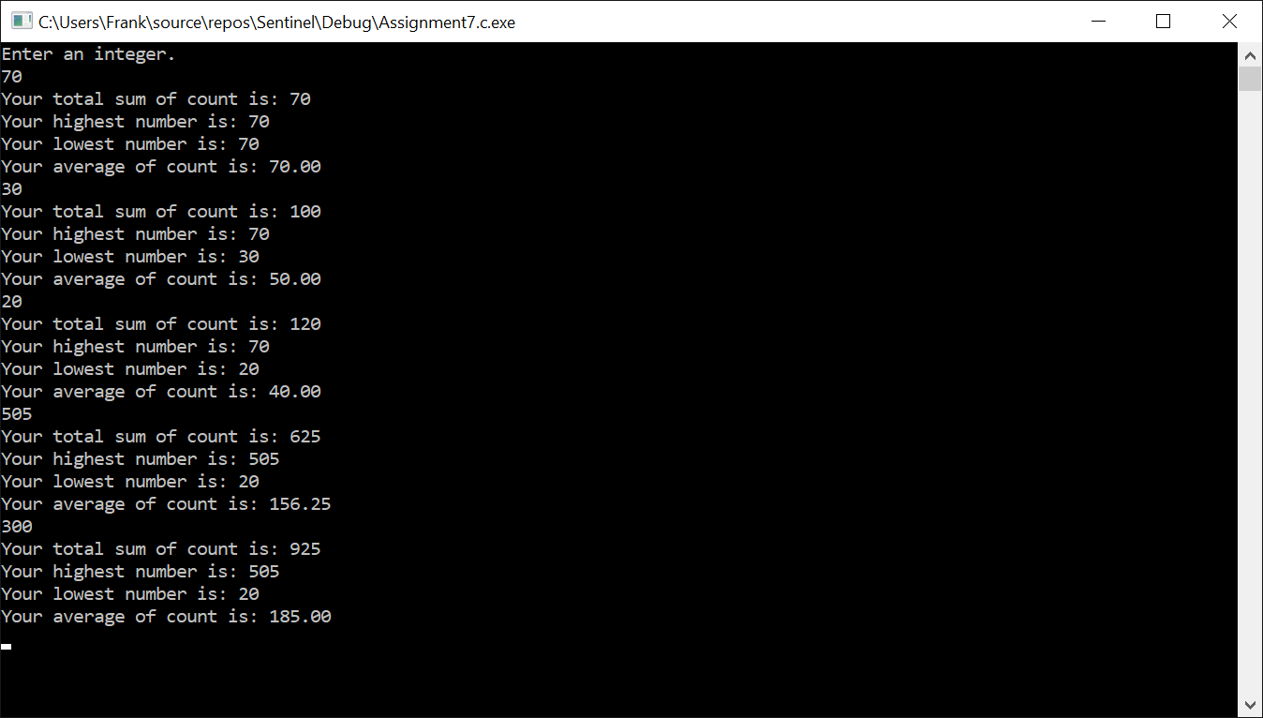

**Assignment 7 – Programming**

We want to find the average for the sum of values, using the number of values to divide the total sum of values, as well as finding the highest and lowest number in the program.

**IPO**

|  |  |  |
| --- | --- | --- |
| **Input**  Input, count, sum, Nvalues, Lvalue, Hvalue, (double) average | **Processing**  Enter **an integer** for **input,**  while input is not 0, sum continues to add values, while **count** provides the **number of values entered,**  if **input** is greater than **Hvalue**,  it becomes **Hvalue**  if **input** is less than **Lvalue**,  it becomes **Lvalue**  sum is divided by the number of values to output the average. | **Output**  Output the average of the values entered, the amount of values, the lowest value and the highest value. |

**Test Case**

|  |  |  |
| --- | --- | --- |
| Input | Average | Result |
| 43 | 43/1 | Total sum – 43  Highest Number- 43  Lowest Number- 43  Average - 43 |
| 100 | 143/2 | Total sum –143  Highest Number- 100  Lowest Number- 43  Average – 71.50 |
| 300 | 443/3 | Total sum – 443  Highest Number- 300  Lowest Number- 43  Average – 147.67 |
| 41 | 484/4 | Total sum – 484  Highest Number- 300  Lowest Number- 41  Average – 121.00 |
| 38 | 522/5 | Total sum – 522  Highest Number- 300  Lowest Number- 38  Average – 104.40 |

|  |  |  |
| --- | --- | --- |
| Input | Average | Result |
| 50 | 50/1 | Total sum – 50  Highest Number- 50  Lowest Number- 50  Average – 50.00 |
| 10 | 60/2 | Total sum – 60  Highest Number- 50  Lowest Number- 10  Average – 30.00 |
| 200 | 260/3 | Total sum – 260  Highest Number- 200  Lowest Number- 10  Average – 86.67 |
| 30 | 290/4 | Total sum – 290  Highest Number- 200  Lowest Number- 10  Average – 72.50 |
|  |  |  |

|  |  |  |
| --- | --- | --- |
| Input | Average | Result |
| 70 | 70/1 | Total sum – 70  Highest Number- 70  Lowest Number- 70  Average – 70.00 |
| 30 | 100/2 | Total sum –100  Highest Number- 70  Lowest Number- 30  Average – 50.00 |
| 20 | 120/3 | Total sum – 120  Highest Number- 70  Lowest Number- 20  Average – 40.00 |
| 505 | 625/4 | Total sum – 625  Highest Number- 505  Lowest Number- 20  Average – 156.25 |
| 300 | 925/5 | Total sum – 925  Highest Number- 505  Lowest Number- 20  Average – 185.00 |